EXERCISE #2 PAST SIMPLE
NAME: ______________________________________________ GRADE: CLEI 5 DATE__________
- Put the verbs into the simple past:
- Last year I (go) to England on holiday.
- It (be) fantastic.
- I (visit) lots of interesting places. I (be) with two friends of mine .
- In the mornings we (walk) in the streets of London.
- In the evenings we (go) to the cinema.
- The weather (be) strangely fine.
- It (not / rain) a lot.
- But we (see) some beautiful rainbows.
- Where (spend / you) your last holiday?

- Complete the table in simple past.

Affirmative | Negative | Interrogative

HE wrote a book
 | She didn’t dance at the party
 |  | Did they speak with their friends

- Put the sentences in the correct order.
- Last week/we / to Miami/arrived _____________________________________________________
- Didn´t /sing /in the concert /Shakira /yesterday __________________________________________
- Visited / my grandma/ I /last year____________________________________________________
- Go / you / did / yesterday /to school/ __________________________________________________
- Did / where/she/buy / that car. ______________________________________________________

- Choose the correct answer according to the picture.
- What happened yesterday
- He buy a car yesterday
- The boy bought a present yesterday
- She buys some candies
- Kathy was thirsty two hours ago
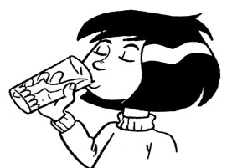
- She drinks soda
- She didn’t drink water
- She drank a glass of water
- He don’t drink soda

- Where did they go last weekend?

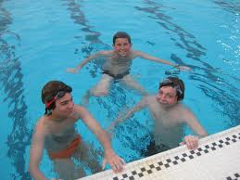

- They goed to school
- They stayed home
- They went to a swimming pool
- They swim in the river
- According to the picture …
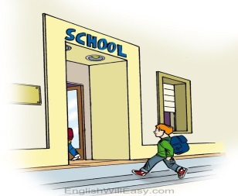
- Peter didn’t go to school
- He went to a party
- He went to school
- He goed to his house

