|  |  |  |
| --- | --- | --- |
| **,,,,,** | INSTITUCIÓN EDUCATIVA JUAN ECHEVERRY ABAD  “Educamos con calidad y formamos seres humanos competentes” |  |
|  |
| **Recuperación** | **Página: 1 de 1** |

**NAME:** ____________________________ **GRADE**: NOVENO 9° **DATE: __________**

**TEMAS:**

Description my family.

Grammar: Saxon possessive and adjectives

Possessive genitive (‘s)

Present events

Reading comprehension:

Free time activities

Past simple vs past continuous

Épocas culturales

MIS PLANES EN EL FURURO: Will vs going to

**DESEMPEÑOS:**

Descripciones sencillas sobre diversos asuntos cotidianos de mi entorno.

Aplicación de estructuras gramaticales del presente simple para describir acciones cotidianas.

Narración o descripción de forma sencilla de hechos y actividades que planeo llevar a cabo.

Comprensión de textos cortos escritos y orales narran eventos del pasado.

**IMPORTANTE:**

Debe resolver cada uno de los puntos del taller con mucha dedicación. Para tal fin es necesario repasar los apuntes en su cuaderno de los periodos anteriores y consultar en la web aquellos temas que se le dificulten. También puede buscar información en el mi blog ( www.arbeyteacher.jimdo.com )

**Actividad # 1**

Consulta los usos del **posesivo o genitivo sajón** y escribe 20 frases u oraciones como ejemplo de sus diferentes usos.

**Actividad #2**

Haga un descripción de su familia y luego diseñe un diagrama de su árbol familiar materno y otro de su árbol familiar paterno, luego diga la relación suyo con los otros miembros.

**Actividad # 3**

Escriba un texto de mediana extensión donde describa cuáles son sus sueños, planes, metas, propósitos o aspiraciones en el corto, mediano y largo plazo. ( utilice el futuro simple will o to be going to)

**Actividad # 4**

**Lea el texto y complete las respuestas.**

Sandra and Betty are sitting in the park, Sandra asks Betty:' Tell me about your family'

**Betty:**' My family is a rather small one, with only three people, my father, my mother and me. My father is a doctor. My mother is a middle-school teacher. I am still a student. My mother is very gentle and soft while my father is a little bit hot-tempered. We love each other very much. Although sometimes we might become angry at one another, very soon we will forget the unpleasant things. We're a happy family, how about you?'

**Sandra**:' I have a big family with seven people, my grandparents, parents, two brothers and me. We take care of one another, share housework, and often communicate all together.'

1. What is Betty's father's job? He is ­­­_________________________

2. How is Betty's mom's temper? She is __________________________

3. How many people are there in Sandra's family? There are ________________________

4. What does Betty think about her family? She thinks that they're a ______________ family.

5. Where are Sandra and Betty meeting? They are meeting in _________________

6. What is Betty's mother's job? She is _________________________

7. How is Betty's father's temper? He is _________________________

8. Which kind of family has Betty? She has _________________________

9. What is Betty doing in life? She is _____________________________

**EXERCISES**

1. **Fill in the correct member**
2. My mother's sister is my 
3. My daughter's brother is my .
4. My father's daughter is my .
5. My mum and dad are my .
6. My sister's son is my .
7. My aunt's son or daughter is my .
8. My father's brother is my .
9. My mother's father is my .
10. My daughter's son is my .
11. My brother's daughter is my .
12. **Complete with the correct possessive adjective(**my,your,his,her,its,our,their)
13. Two students didn't do. ______ mathematics homework.
14. I have a car. ______ car is black.
15. We have a dog._______name is Pancho.
16. Nancy is from England. ______ husband is from Australia.
17. Farid and Nadia go to a high school. _____little brother goes to primary school.
18. **write the relationship according to the picture**

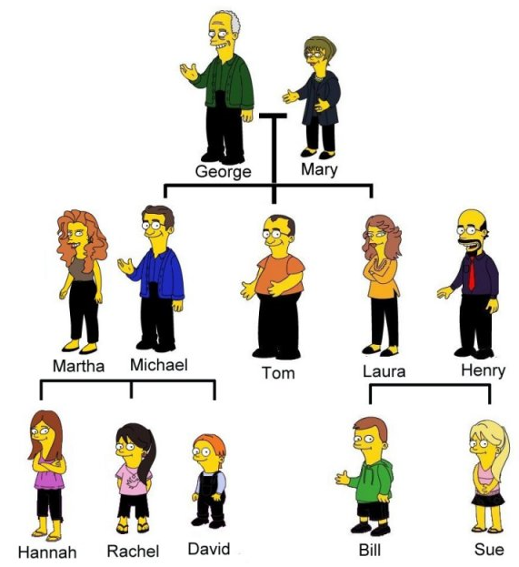

1. David is Mary's ________________________
2. Tom is Laura's _________________________
3. Mary is Rachel's ________________________
4. Martha is Hannah's ______________________
5. George is Henry's ________________________
6. Laura is David's ________________________
7. Sue is George's _________________________
8. Mary is George's ________________________
9. Laura is Martha's ________________________

D**. Conjugue los verbos en paréntesis en Past Perfect or Simple Past.**

1) After Fred _________ (to spend) his holiday in Italy he ________ (to want) to learn Italian.

2) Jill _______ (to phone) Dad at work before she__________ (to leave) for her trip.

3) Susan________ (to turn on) the radio after she_________ (to wash) the dishes.

4) When she_________ (to arrive) the match________ already______(to start).

5) After the man________ (to come) home he (to feed) the cat.

6) Before he__________ (to sing) a song he__________ (to play) the guitar.

7) She________ (to watch) a video after the children__________ (to go) to bed.

8) After Eric_________ (to make) breakfast he___________(to phone) his friend.

9) I ___________(to be) very tired because I _____________(to study) too much.

10) They__________ (to ride) their bikes before they _____________(to meet) their friends.

**E. Haga un listado de deportes que usted reconozca y clasifíquelos en de conjuntos e individuales. Consulte en el diccionario el vocabulario que no conozca.**

|  |  |
| --- | --- |
| TEAM SPORTS | INDIVIDUAL SPORTS |
| * Soccer | * Tennis |

**Seleccione tres deportes populares en tu país. Diga por que le gusta y por qué no le gusta.**

|  |  |
| --- | --- |
| **sports** | **Do you like ? why?** |
| 1._____________ |  |
| 2. ____________ |  |
| 3. ____________ |  |