|  |  |  |
| --- | --- | --- |
|  | INSTITUCIÓN EDUCATIVA JUAN ECHEVERRY ABAD  “Educamos con calidad y formamos seres humanos competentes” |  |
|  |
| **Recuperación** | **Página: 1 de 1** |

**NAME:** ____________________________ **GRADE**: octavo 8° **DATE:** _____________

**TEMAS:**

Present and past events

Present and past of to be

Continuous present actions

Simple past structures: auxiliary did Narrating stories: Regular and irregular verbs General Vocabulary

**DESEMPEÑOS:**

Identificación de relaciones de significado expresadas en textos sobre temas que me son familiares.

Respuestas para preguntas de información wh-questions sobre actividades cotidianas.

Formulación de preguntas sobre acontecimientos del pasado relacionados con su vida.

Descripción de eventos y acciones que están ocurriendo a su alrededor.

**IMPORTANTE**:

Debe desarrollar todos los puntos del taller, repasar los apuntes de su cuaderno y consultar aquellos temas, vocabulario y estructuras que no recuerde.

A**. complete las oraciones con la forma correcta del verbo TO BE en pasado, luego tradúzcalas.**

1) I __________ in Canberra last spring.

2) We ________ at school last Saturday.

3) Tina_________ at home yesterday.

4) He __________ happy.

5) Robert and Stan ________ Garry's friends.

6) You ________ very busy on Friday.

7) They _________ in front of the supermarket.

8) I_________ in the museum.

9) She______ in South Africa last month.

10) Jessica and Kimberly ________ late for school.

B. **complete las frases con la forma THERE WAS or THERE WERE.**

1. _______________ a bank near my house.
2. _________________ten children in the park.
3. ________________ two kittens in the basket.
4. _________________ a small shop between the bank and the supermarket.

5. _______________ many bottles of milk in the fridge. 6. ______________some pencils on the desk.

7. ______ __________ only one book on the table.

8. ________________ an old man in the street.

9.________________ a lot of noise in the classroom.

10.________________ a huge crocodile in the river.

**C. escoja un lugar que haya visitado y haga una descripción tipo inventario. como era, que había y que no había. ( UTILICE THERE WAS/WERE )**

**D. lea el texto y responda las preguntas. Resalte las palabras desconocidas.**

**ANTIOQUIA’S FLAG**

its origin was in Antioquia University and It was created by all its official representations. In 1962, it was declared as the official pattern symbol in our department. It has two equal strips. The superior strip is white and the inferior one is green. The white green means the integrity, obedience, triumph and purity of our population. The green means besides our mountains, the hopeless, the abundance, the freedom, the faith the service and the respect for everything.

1. Where was Antioquia flag origin?
2. What happened in 1962?
3. What does the green color mean?
4. Which color represents the integrity of population?
5. Which color represent the respect for everything

E**. haga un glosario con aquellas palabras que no conoce**

F. **relacione la palabra de la derecha con su definición poniendo el número en frente.**

|  |  |  |  |  |
| --- | --- | --- | --- | --- |
| 1 | a place to sleep |  | Accident | |
| 2 | don´t leave it home on a cloudy day |  | water | |
| 3 | A person who plan trips |  | journalist | |
| 4 | The weather is really cold |  | school | |
| 5 | A person who design houses |  | umbrella | |
| 6 | You might need a list |  | policeman | |
| 7 | It is needed to do the dishes |  | bed | |
| 8 | You sleep under this when you go camping |  | hunter | |
| 9 | He should make you to obey |  | winter | |
| 10 | It´s bigger than a town |  | shopping | |
| 11 | A crash between two cars |  | jail | |
| 12 | You study in a … |  | city | |
| 13 | Is someone who help you in law |  | | dentist | |
| 14 | Smugglers are taken in a… |  | | secretary | |
| 15 | Paint pictures, sketches, and so on |  | | tent | |
| 16 | Write for a newspaper or magazine |  | | receptionist | |
| 17 | Take care of people`s teeth |  | | Travel agent | |
| 18 | Animals are afraid of this man |  | | Lawyer | |
| 19 | Answer the phone |  | | architect | |
| 20 | Helps others who work in an office |  | | artist | |

1. **complete las oraciones con la forma correcta en pasado del verbo en paréntesis.**
2. Last year I (go)  to England on holiday.
3. It (be)  fantastic.
4. I (visit)  lots of interesting places. I (be)  with two friends of mine .
5. In the mornings we (walk)  in the streets of London.
6. In the evenings we (go)  to the cinema.
7. The weather (be)  strangely fine.
8. It (not / rain)  a lot.
9. But we (see)  some beautiful rainbows.
10. Where (spend / you)  your last holiday?
11. **Complete la table con la forma que hacen falta. Si se le da una oración positiva, llévela a negativa e interrogativa y viceversa.**

|  |  |  |
| --- | --- | --- |
| **Affirmative** | **Negative** | **Interrogative** |
| HE wrote a book |  |  |
|  | She didn’t dance at the party |  |
|  |  | Did they speak with their friends |
|  | My family didn’t go to the beach this summer. |  |
| they studied in this school |  |  |
|  |  | did your friends visit you yesterday? |

1. **ponga los elementos de la oración en el orden correcto de suerte que sea coherente.**
2. *Last week / we / to Miami / arrived _____________________________________________________*
3. *Didn´t / sing / in the concert /Shakira / yesterday ______________________________________________*
4. *Visited / my grandma / I / last year*

*______________________________________________*

1. *Go / you / did / yesterday /to school/ _______________________________________________*
2. *Did / where /she /buy / that car. ________________________________________________*
3. **Escoja 15 inventos de los dos últimos siglos y complete el resto de la información del cuadro.**

|  |  |  |  |
| --- | --- | --- | --- |
| **INVENTIONS THAT CHANGED OUR LIFE** | | | |
| **Name of the inventions** | **Inventors** | **The year of invention** | **The function of the invention** |
|  |  |  |  |
|  |  |  |  |
|  |  |  |  |
|  |  |  |  |
|  |  |  |  |
|  |  |  |  |
|  |  |  |  |
|  |  |  |  |
|  |  |  |  |
|  |  |  |  |
|  |  |  |  |
|  |  |  |  |
|  |  |  |  |
|  |  |  |  |
|  |  |  |  |

**K. diga que están hacienda las personas de las imagines. Use el presente continuo.**

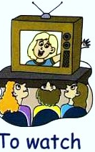**­­­­­­­­­­­­­­­­­­­­­** 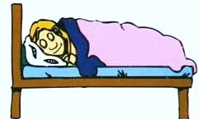 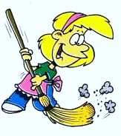

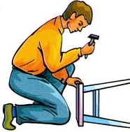 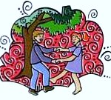 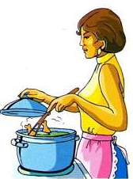

 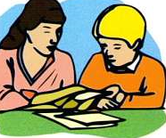 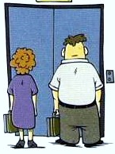

1. **Relacione la vocabulario del universo con su correcta definición. Algunas palabras sobran**

|  |
| --- |
| **Asteroids      Comets      eclipse      full moon      Jupiter      Mars      Mercury      Moon      new moon      Planets      Pluto      revolution      Rotation      satellite      Saturn      seasons      Solar System      Stars      Sun      Venus** |

Principio del formulario

1. The movement of the Earth around the Sun is  .   
   2.  is the group formed by the Sun and the eight planets.  
   3.  is the biggest planet in the Solar System.  
   4. It's midday and a shadow covers the Sun and it disappears. It's an    
   5. A  is a body that turns around a planet.  
   6.  is the closest planet to the Sun.  
   7. Winter, spring, summer and autumn are .  
   8.  orbit around the Sun.  
   9. The  lights and heats the Earth.  
   10. .  orbit the Sun on a very large trajectory and often they show a tail.

11.   orbit the Sun on a very large trajectory and often they show a tail.  
12. When the moon is a completely illuminated circle it's called.  
13.  is a famous planet because of its rings.  
14. The  moves around the Earth.  
15.  belt is a group of rocky bodies between Mars and Jupiter.  
 is often called the red planet.