TALLER DE APOYO SEGUNDO PERIODO
REIFORCEMENT WORKSHOP 2ND PERIOD (8°)
STUDENT:___________________________________ GRADE: _________DATE:_____________
TEACHER: __________________________________ SUBJECT: _______________________
- Clasifique los verbos en regulares o irregulares y ponga sus respectivas formas en pasado como en el ejemplo.
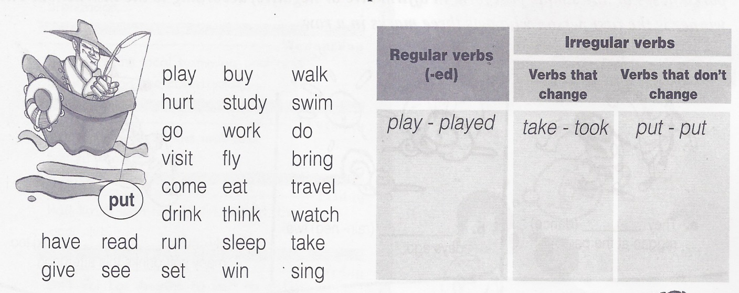

- en la tabla encuentra 10 verbos ( del 1 - 10) y 10 expresiones ( de A - J). luego una los verbos con las frases correspondientes y forme oraciones en pasado, como en el ejemplo.
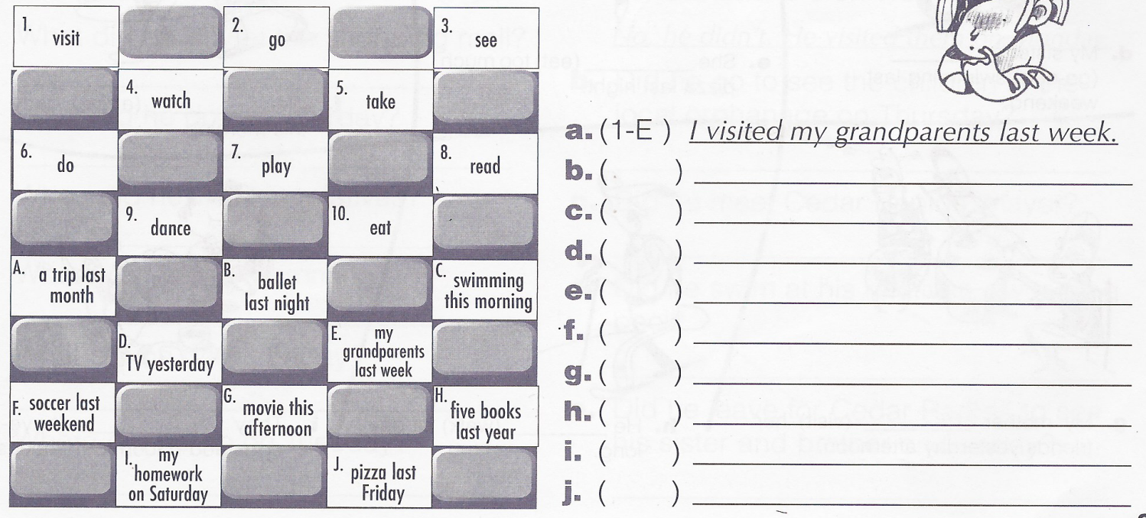
3. relacione el desastre natural a su definición.
1 | avalanche |  | the rising of a body of water and its overflowing onto normally dry land
2 | drought |  | a large mass of ice floating at sea; usually broken off of a polar glacier
3 | earthquake |  | the trees and other plants in a large densely wooded area
4 | fire |  | a slide of large masses of snow and ice and mud down a mountain
5 | flood |  | a powerful circular current of water (usually the result of conflicting tides)
6 | forest |  | shaking and vibration at the surface of the earth.
7 | rainstorm |  | the process of combustion of inflammable materials producing heat and light and smoke
8 | whirlpool |  | droplets of water vapor suspended in the air near the ground
9 | iceberg |  | a cataclysm resulting from a destructive sea wave caused by an earthquake
10 | tsunami |  | a storm with rain
11 | fog |  | a shortage of rainfall

4. was or were into the gaps.
1) I __________ in Canberra last spring.
2) We ________ at school last Saturday.
3) Tina_________ at home yesterday.
4) He __________ happy.
5) Robert and Stan ________ Garry's friends.
6) You ________ very busy on Friday.
7) They _________ in front of the supermarket.
8) I_________ in the museum.
9) She______ in South Africa last month.
10) Jessica and Kimberly ________ late for school.
5. Complete with THERE WAS or THERE WERE.
- _______________ a bank near my house.
- _________________ten children in the park.
- ________________ two kittens in the basket.
- _________________ a small shop between the bank and the supermarket.
- _______________ many bottles of milk in the fridge.
6. ______________some pencils on the desk.
7. ______ __________ only one book on the table.
8. ________________ an old man in the street.
9._________________ a lot of noise in the classroom.
10._________________ a huge crocodile in the river.

6. Read the text and answer the questions
ANTIOQUIA’S FLAG
its origin was in Antioquia University and It was created by all its official representations. In 1962, it was declared as the official pattern symbol in our department. It has two equal strips. The superior strip is white and the inferior one is green. The white green means the integrity, obedience, triumph and purity of our population. The green means besides our mountains, the hopeless, the abundance, the freedom, the faith the service and the respect for everything.
- Where was Antioquia flag origin?
- What happened in 1962?
- What does the green color mean?
- Which color represents the integrity of population?
- Which color represent the respect for everything
7. haga un glosario con aquellas palabras que no conoce
8. MATCH THE WORDS ON THE RIGHT WITH THE CORRECT DEFINITION
1 | a place to sleep |  | Accident
2 | don´t leave it home on a cloudy day |  | water
3 | A person who plan trips |  | journalist
4 | The weather is really cold |  | school
5 | A person who design houses |  | umbrella
6 | You might need a list |  | policeman
7 | It is needed to do the dishes |  | bed
8 | You sleep under this when you go camping |  | hunter
9 | He should make you to obey |  | winter
10 | It´s bigger than a town |  | shopping
11 | A crash between two cars |  | jail
12 | You study in a … |  | city
13 | Is someone who help you in law |  |  | dentist
14 | Smugglers are taken in a… |  |  | secretary
15 | Paint pictures, sketches, and so on |  |  | tent
16 | Write for a newspaper or magazine |  |  | receptionist
17 | Take care of people`s teeth |  |  | Travel agent
18 | Animals are afraid of this man |  |  | Lawyer
19 | Answer the phone |  |  | architect
20 | Helps others who work in an office |  |  | artist

